**Papers written by Australian Maths Software**

**SEMESTER ONE YEAR 12**

**MATHEMATICS SPECIALIST**

**REVISION 3**

**UNIT 3**

**2016**

**Section Two**

**(Calculator–assumed)**

**Name**: _________________________________

**Teacher:** ________________________________

**TIME ALLOWED FOR THIS SECTION**

Reading time before commencing work: 10 minutes Working time for section: 100 minutes

**MATERIAL REQUIRED / RECOMMENDED FOR THIS SECTION**

**To be provided by the candidate**

Standard items*:* pens, pencils, pencil sharpener, highlighter, eraser, ruler.

Special items: drawing instruments, templates, notes on up to two unfolded sheet of A4 paper, and up to three calculators approved for use in the WACE

examinations.

**IMPORTANT NOTE TO CANDIDATES**

No other items may be taken into the examination room. It is your responsibility to ensure that you do not have any unauthorised notes or other items of a non–personal nature in the examination room. If you have any unauthorised material with you, hand it to the supervisor before reading any further.

**To be provided by the supervisor**

Question/answer booklet for Section Two.

Formula sheet retained from Section One.

MATHEMATICS SPECIALIST, Semester One Calculator-assumed

**Structure of this examination**

|  | Number of questions  available | Number of  questions to  be answered | Working  time  (minutes) | Marks  available | Percentage of exam |
| --- | --- | --- | --- | --- | --- |
| Section One  Calculator—free | **5** | **5** | **50** | **50** | 35 |
| **Section Two**  **Calculator—assumed** | 12 | 12 | 100 | 100 | **65** |
|  |  |  | Total marks | 150 | 100 |

**Instructions to candidates**

1. The rules for the conduct of this examination are detailed in the Information Handbook. Sitting this examination implies that you agree to abide by these rules.

2. Write your answer in the Question/Answer booklet.

3. You must be careful to confine your responses to the specific questions asked and to follow any instructions that are specific to a particular question.

4. Spare pages are provided at the end of this booklet. If you need to use them, indicate in the original answer space where the answer is continued i.e. give the page number.

5. Show all your working clearly. Your working should be in sufficient detail to allow your answers to be checked readily and for marks to be awarded for reasoning. Incorrect answers given without supporting reasoning cannot be allocated any marks. For any question or part question worth more than two marks, valid working or justification is required to receive full marks. If you repeat an answer to any question, ensure that you cancel the answer you do not wish to have marked.

6. It is recommended that you do not use pencil, except in diagrams.

7. The Formula Sheet is not to be handed in with your Question/Answer booklet.

2

MATHEMATICS SPECIALIST, Semester One Calculator-assumed

6. (19 marks)

(a) Two particles, P1 and P2, are travelling in circular paths as defined by the equations

***r***1 (*t*) = (*sin*(*t*))***i*** +(*cos*(*t*)) ***j*** and ***r***2 (*t*) = (*sin*(*t*))***i*** −(*cos*(*t*))***j***. (i) Show that both paths have the same Cartesian graph and explain why. (4)

(ii) Sketch the path of the particles below. (2) 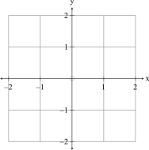

(iii) Determine the starting point and direction of travel for both particles. (2)

π

(iv) How far apart are the particles at (2) 3? *t* =

3

MATHEMATICS SPECIALIST, Semester One Calculator-assumed

(b) The position vector of a particle at time is given by *t*

***r***(*t*) = (6 *sin*(*t*) + 2*cos*(*t*))***i*** + (6 *sin*(*t*) − 2*cos*(*t*)) ***j***. The relationship is graphed below:

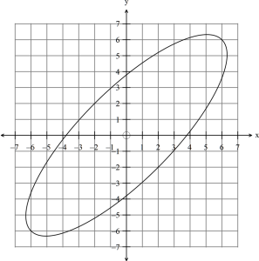

(i) Find the expressions for the velocity and acceleration of ***v*** (*t*) and ***a*** (*t*), the particle and hence show that . (4) ***a*** (*t*) = -***r***(*t*)

4

MATHEMATICS SPECIALIST, Semester One Calculator-assumed

(ii) Find an expression for (3) ***r***(*t*)∙ ***v*** (*t*)

(iii) For what values of for is the position vector perpendicular to *t t* ∈[0***,***π] the velocity vector? (2)

5

MATHEMATICS SPECIALIST, Semester One Calculator-assumed

7. (7 marks)

A particle has a position vector , a velocity of and an acceleration of at ***r***(*t*) ***v*** (*t*) ***a***(*t*)any time *t*.

(a) Find the expression for given and ***r***(*t*) (*t*) = ( *cos*(5*t*) +*sin*(5*t*))*dt* ∫ ***r i j***

⎛ π ⎞ = ~~−~~ ⎜ ~~⎟~~

(3) 1

⎝ ⎠ ***r j .***

5 5

(b) Determine the expression for given ***a*** (*t*) (*t*) = ( *cos*(5*t*) +*sin*(5*t*))*dt* . (2) ∫ ***r i j***

(c) Using the results of (a) and (b) find the position vector and the velocity at *t* =0.(2)

6

MATHEMATICS SPECIALIST, Semester One Calculator-assumed

8. (3 marks)

Find a unit vector that is normal to the plane containing the points

*A*(1***,***1***,***1), *B*(1***,***0***,***1) and *C*(−2***,***0***,***1). (3)

7

MATHEMATICS SPECIALIST, Semester One Calculator-assumed

9. (6 marks)

(a) Given the points *P*(1***,*** 0***,*** − 2) ***,****Q*(−1***,*** 2***,*** 1) and *R*(0***,*** 3***,*** 1) and*S*(*a****,*** *b****,*** *c*)find the coordinates of point such that is a parallelogram (in cyclic *S PQRS* order). (3)

8

MATHEMATICS SPECIALIST, Semester One Calculator-assumed

⎛ ⎞ ⎛− ⎞

2 1

⎜ ⎟ ⎜ ⎟ = =

***a b***

Given

0 3

and

⎜ ⎟ ⎜ ⎟ 3 4

⎝ ⎠ ⎝ ⎠

(b) (i) evaluate (1) ***a***×***b***

(ii) explain how to find the area of the triangle given and *AOBOA*=***a****OB* = ***b***. (2)

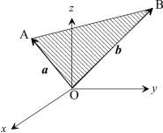

9

MATHEMATICS SPECIALIST, Semester One Calculator-assumed

10. (7 marks)

(a) (i) Find the vector equation of the plane through and that contains *A*(1***,***2***,***3) 1 1

⎛ ⎞ ⎛ ⎞

⎜ ⎟ ⎜ ⎟ =

the line (3) ( )

***r*** *t +t*

0 4

.

1 3

⎝ ⎠ ⎝ ⎠

(ii) Determine whether or not the point belongs to the line in (i). *M*(6***,***20***,***16) (1)

10

MATHEMATICS SPECIALIST, Semester One Calculator-assumed

(b) John and Jack are twins, fifteen years old and competitive. They both see the birthday parcel their Dad hid on the branch of a tree at at the same time. (0***,***5***,***3)⎛−⎞

1

⎜ ⎟

John is at and leaps for the parcel with a velocity of . (3***,***2***,***0)

1

1

⎝ ⎠

1

⎛ ⎞⎜ ⎟

James is at and leaps for the parcel with a velocity of . (−2***,***1***,***0)

2

⎝ ⎠***.***

15

(i) How long does it take John to reach ? (1) (0***,***5***,***3)

(ii) Who gets to the parcel first? (1) (iii) Which boy, John or James, moves with the greatest speed? (1)

11

MATHEMATICS SPECIALIST, Semester One Calculator-assumed

11. (6 marks)

(a) Find the constant such that is perpendicular to *m* ***p*** = 2*m****i***+ *m****j***+ 2***k q***1

⎛ ⎞

⎜ ⎟ = −

where .

***q***

1

(2)

3

⎝ ⎠

2 2 2

(b) (i) Given is the Cartesian equation of a ( ) ( ) ( )

*x* −1 + *y* + 3 + *z* − 2 = 25 sphere, determine whether or not the point is inside, outside or on *P*(3***,***1***,***1) the sphere. (2)

(ii) Determine the vector equation of the sphere with Cartesian equation ( ) ( ) ( ) (2) 2 2 2

*x* −1 + *y* + 3 + *z* − 2 = 25.

12

MATHEMATICS SPECIALIST, Semester One Calculator-assumed

12. (6 marks)

A ball rolls across the top of a table with a speed of 1 m/s*.* The top of the table is exactly 1 metre above the floor.

Gravity exerts an acceleration of . ( )

*t* 9.8 m/s− ***a*** = − ***j***

2

(a) Exactly how far from the edge of the table does the ball hit the floor? (5)(b) How long did it take the ball to hit the floor? (1)

13

MATHEMATICS SPECIALIST, Semester One Calculator-assumed

13. (12 marks)

(a) Define the set of points shaded on the set of axes below. (3) 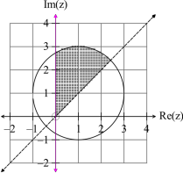

(b) Sketch on the set of axes below. (3) *z* −1− 2*i* = *z* + 2 − *i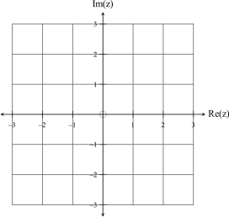*

14

MATHEMATICS SPECIALIST, Semester One Calculator-assumed

(c) (i) Simplify . (1) (1+ 3*i*)(1+ *i*) (ii) If show that and (3) *z* = (1+ 3*i*)(1+ *i*) *z* = 2 ~~2~~ ( ~~)~~ 34ππ*arg ~~z~~* =+*.*

(iii) Hence show that (2) 7 1 3

⎛ π ⎞ +

⎝ ⎠ *sin .*

⎜ ~~⎟~~ =

12 2 2

.

15

MATHEMATICS SPECIALIST, Semester One Calculator-assumed

14. (17 marks)

(a) Given *g* ( *x*) = *x*

(i) Explain why an inverse exists for the function . (2) *g*

(ii) Sketch the function on the set of axes below. ( ) ( )

1 and− *y* = *g x y* = *g x*

Label each graph. (2)

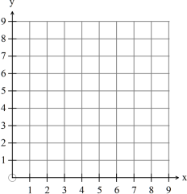

(iii) Determine the equation, the domain and the range of . (2) ()−1 *y* =*gx*

(iv) Find . (1) ( ) − *g*

1 4

16

MATHEMATICS SPECIALIST, Semester One Calculator-assumed

(b) Given show that (2) *f* ( *x*) = 2*x* −1 and *g* ( *x*) = 2 − *x f* ( *g* ( *x*))=*g*(*f* (*x*))*.*

(c) Given ( ) ( )

2

*p x* = 1− *x* and *q x* = *x* − 3

(i) find an expression for and state the values of for which the *y* = *p*(*q*( *x*)) *x*composite function is defined. (3)

(ii) find an expression for and determine whether or not *y* = *q*( *p*( *x*)) *q*( *p*(2))is defined. (3)

(iii) state the range of . (2) *y* = *q*( *p*( *x*))

17

MATHEMATICS SPECIALIST, Semester One Calculator-assumed

15. (8 marks)

(a) Consider the graphs of and . *f* ( *x*) = *x* ( ~~)~~ 21 *g ~~x~~* =*x*

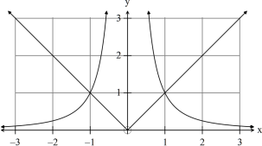

(i) Write down the solutions to . (1) 21 *x* =*x*

(ii) Shade on the number line below the values of such that (2) *x*21*x*<*. x*

(b) Solve the equation (5) 1− *x* = 1− 2*x*

18

MATHEMATICS SPECIALIST, Semester One Calculator-assumed

16. (4 marks)

Determine the equation of the function graphed below: (4)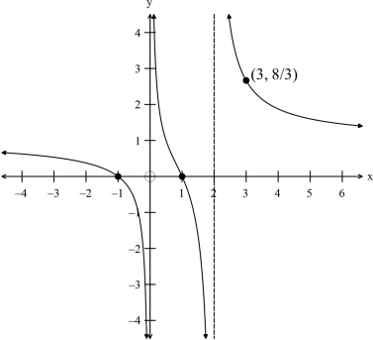

19

MATHEMATICS SPECIALIST, Semester One Calculator-assumed

17. (5 marks)

Use de Moivre’s Theorem to prove that . ( ) ( ) ( ) ()()3 3*sin* 4θ = 4*cos* θ *sin* θ−4*cos*θ*sin*θ(5)

**END OF SECTION TWO**

20